

SIMATS ENGINEERING

Saveetha Institute of Medical and Technical Sciences
Chennai- 602105

Student Name:A.Sathwika Reddy Reg. No.: 192525274
Course Code: CSA0619 Slot:D
Course Name : Design and Analysis of Algorithms
Course Faculty: Dr F. Mary Harin Fernandez

CO1_ASSESMENT TOOL 1
8)

Aim :To analyze the time complexities of three rendering algorithms, O(n), O(n log n), and O(n²), using asymptotic notation and determine the most efficient algorithm for high-resolution gaming applications.

Algorithm
- Start the program.
- Read the input size n.
- Calculate the values for O(n), O(n log n), and O(n²).
- Display the calculated values.
- Compare the growth rates of all three algorithms.
- Identify the most efficient algorithm.
- Display the conclusion.
- Stop.
OUTPUT:
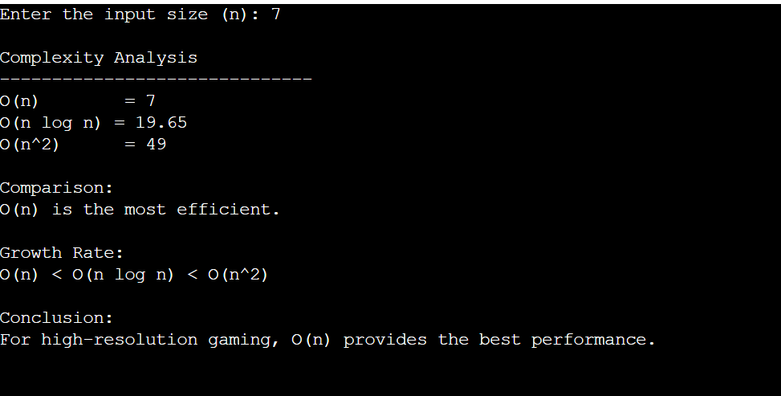

Analysis
- O(n) grows linearly with the input size and performs the fewest operations.
- O(n log n) grows slightly faster than linear and is suitable for efficient sorting and searching tasks.
- O(n²) grows quadratically and becomes inefficient as the input size increases.
- For high-resolution rendering, algorithms with lower complexity ensure faster frame rates and smoother gameplay.

Result:
The program successfully analyzed the growth rates of O(n), O(n log n), and O(n²). It concluded that O(n) is the most efficient algorithm for gaming engines dealing with high-resolution inputs because it has the lowest growth rate.

24)

Aim:To analyze the recurrence relation T(n)=5T(n/2)+n using the Master Theorem and determine its asymptotic time complexity.

Algorithm:
- Start the program.
- Read the problem size n.
- Identify the Master Theorem parameters:
  - a = 5
  - b = 2
  - f(n) = n
- Calculate log₂5.
- Compare f(n) with n^(log₂5).
- Apply the appropriate Master Theorem case.
- Display the time complexity.
- Stop.
OUTPUT:
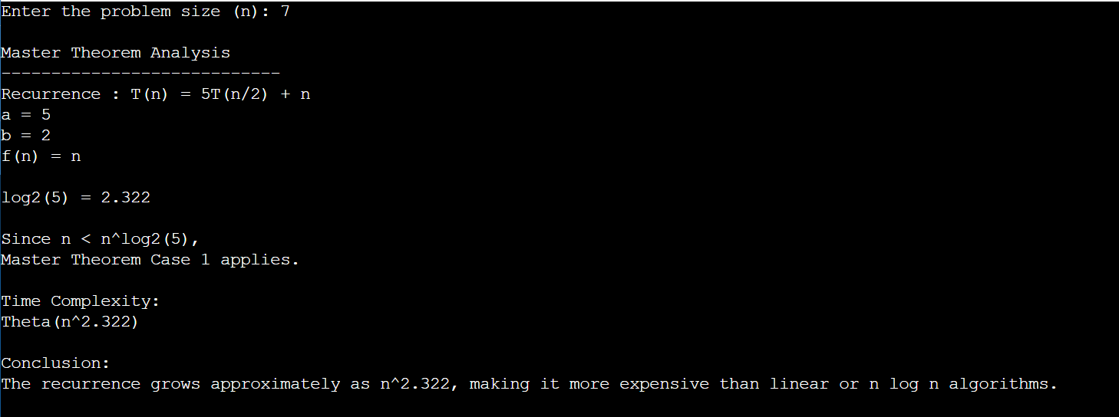

Analysis:
Given:
T(n)=5T(n/2)+nT(n)=5T(n/2)+nT(n)=5T(n/2)+n
Parameters:
- a = 5
- b = 2
- f(n)=n
Calculate
log⁡25≈2.322\log_2 5 \approx 2.322log2​5≈2.322
Since
f(n)=O(n2.322−ϵ)f(n)=O(n^{2.322-\epsilon})f(n)=O(n2.322−ϵ)
for some ε > 0, Case 1 of the Master Theorem applies.
Therefore,
T(n)=Θ(nlog⁡25)\boxed{T(n)=\Theta(n^{\log_2 5})}T(n)=Θ(nlog2​5)​
which is approximately
Θ(n2.322)\boxed{\Theta(n^{2.322})}Θ(n2.322)​

Result:
The recurrence relation T(n)=5T(n/2)+n was successfully analyzed using the Master Theorem. Since a = 5, b = 2, and f(n)=n, Case 1 applies, resulting in the time complexity Θ(n^log₂5) (approximately Θ(n^2.322)). This indicates that the algorithm becomes computationally expensive as the input size increases, making it less suitable for very large distributed database systems without further optimization.

